|  |  |
| --- | --- |
| cetlogo ***CHEMICAL ENGINEERING TRANSACTIONS***  ***VOL. xxx, 2024*** | A publication of  aidiclogo_grande |
| The Italian Association  of Chemical Engineering  Online at www.cetjournal.it |
| Guest Editors: Valerio Cozzani, Bruno Fabiano, Genserik Reniers  Copyright © 2024, AIDIC Servizi S.r.l. **ISBN** 979-12-81206-11-3; **ISSN** 2283-9216 | |

Safe Management and Risk Evaluation of Pressure Pipes in the Process and Energy Industry

Giovanni Grillonea,\*, Antonino Muratoreb, Eleonora Gencoc, Alberto Firenzed, Maurilio Bellissimoa, Giuseppe Giannellib, Vincenzo Nastasia

aInail, UOT Palermo, Viale del Fante 58/D - 90146 Palermo, Italy

bInail, UOT Como, Via Petrarca 4 - 22100 Como, Italy

cUniversità di Palermo, Scuola di Specializzazione in Medicina del Lavoro, Piazza delle Cliniche, 2 - 90127 Palermo, Italy

dUniversità di Palermo, Dipartimento della Promozione della Salute, Materno-Infantile, di Medicina Interna e Specialistica di Eccellenza “G. D’Alessandro” (PROMISE), Piazza delle Cliniche, 2 - 90127 Palermo, Italy

\*g.grillone@inail.it

Process and energy industries include chemical plants, oil refineries and bio-refineries, power plants, etc., in which a variety of pressure equipment/assemblies are located (steam generators, reactors, heat exchangers, pressure tanks, etc.), which use a very wide range of flammable and/or toxic substances.

This equipment has historically been controlled, both during construction and operation, while the pressure pipes were considered potentially "dangerous" by the legislation only with the entry into force of the first European Directive 97/23/CE (PED Directive) and the European Directive 2014/68/EU, which modifies and integrates the previous one.

The PED directive introduced pressure pipes because they very often cause triggering of accidental events (fires, explosions, toxic releases), involving successively important pressure equipment (steam generators, reactors, heat exchangers, pressure tanks, etc.).

Pressure pipes must be particularly monitored and maintained in Seveso establishments (Seveso Directive - 2012/18/EU).

In this paper authors suggest to the employer an operational framework for the safe management of residual risks of pressure pipes, during operating phase, due to the installation, use and/or reasonably foreseeable improper use of the aforementioned pipes are described here, showing an application example.

It is important to note that, nowadays, there are pipes constructed in accordance with the PED Directive and pipes built before the introduction of these European Directives (the latter lack manufacturer’s certification). Employers in Italy must manage these two different types of pipes in compliance with the Decree of the Ministry of Production Activities No. 329, issued on December 1, 2004, and the Decree of the Ministry of Labour and Social Policies issued on April 11, 2011.

Furthermore, authors describe the main effects on the health of workers and citizens living near industrial plants, due to accidents causing fires, explosions and release of toxic substances.

Keywords: Pressure Pipes Safety (construction and exercise), incidental events, PED directive, Seveso directive, workers’ health, citizens’ health

* 1. Introduction

Pressure pipes are used to move liquids and gases between the various parts of an industrial plant, connecting pressure equipment such as steam generators, reactors, heat exchangers, pressure tanks, etc..

The chemical substances handled are often dangerous and can trigger fires, explosions, toxic releases with serious consequences both for human health (workers and the population living near the industrial plant) and for the surrounding environment, especially in the case of industrial plants falling within the Seveso directive (2012/18/EU), which contain high quantities of dangerous substances.

The employer, in order to manage the pressure pipes present in their industrial plant, must identify those constructed according to the PED directives (97/23/EC or 2014/68/EU) and those built before the abovementioned directives. Afterwards, the employer, in order to manage residual risks and to maintain regular operation of the pressure pipes, verifies that:

* pipes built according with PED directives: the equipment is provided with 1) CE declaration of conformity to the PED directive, 2) identification plate on the pressure equipment, 3) use and maintenance instructions issued by the manufacturer;
* pipes built before the introduction of PED directives: the equipment is built following good engineering practices.

Following authors’ experience in this field, this paper offers the employer a concise framework for safely managing pressure pipes, from the construction phase to the operation phase of the pipes themselves, introducing a method for assessing risks during the operation phase with the aim of protecting health of workers, population and environment.

* 1. Safe management of pressure pipes during operating phase

Pressure pipes, as well as pressure equipment and/or assemblies, introduce a specific risk in the workplace (even if correctly constructed and CE-PED certified) depending on: 1) use condition (pressure, temperature, physical state); 2) place of installation and possible interference with other nearby equipment; 3) type of plant; 4) contained fluid, dangerous or non-dangerous (the dangerous fluids, indicated in the PED directive as group 1, are: explosive, flammable, toxic, oxidising; while the fluids of group 2 are all the other fluids not falling within group 1); 5) Volume (vessels) and Nominal Diameter (DN). The diversity of the abovementioned conditions can lead, for the same type of pipes or pressure equipment/assembly, to different risk levels during operating phase.

Main steps suggested to correctly manage pressurized pipes during the operation phase are:

STEP A). Pressure pipes for the entire plant, with the relative documentation issued by the manufacturer, must be registered. The census must also include pressure pipes already existing before the entry into force of the first PED directive 97/23/EC and not CE-PED certified.

STEP B). Identification of the PED risk category, both for pipes built according to the PED directive and those built before the PED directive, using:

1. for pipes carrying gas: table 6 (Dangerous fluid, group 1) and table 7 (Non-Dangerous fluid, group 2) of the directive PED (Figure 1);
2. for pipes carrying liquids: table 8 (Dangerous fluid, group 1) and table 9 (Non-Dangerous fluid, group 2) of the directive PED (not shown here).

|  |  |
| --- | --- |
| Table 6 of Directive PED: Dangerous fluid    Note: Pipes intended to contain unstable gases belonging, according to Table 6, to categories I or II, are classified in category III (PED Directive 2014/68/EU). | Table 7 of Directive PED: Non-Dangerous fluid    Note: Pipes containing fluids at a temperature above 350 °C belonging, according to Table 7, to category II, are classified in category III (PED Directive 2014/68/EU). |

Figure 1: Table 6 (Dangerous fluid, group 1) and Table 7 (Non-Dangerous fluid, group 2) of Directive PED: identification of risk category of pressure pipes.

It should be noted that for pipes included in tables 6, 7 and 8 the risk category can be: I, II or III; while for pipes falling under table 9 the risk category can be: I or II (for more details, please refer to the PED directive for all the tables relating to the pipes, i.e. tables 6, 7, 8 and 9).

If pipe fall into the category lower than PED risk category I, it is allowed that the equipment do not follow the essential safety requirements included in Annex I of PED directive during the design and construction phase, and the equipment itself can be placed on the market and put into service according to the sound engineering practice in use in the country of manufacture belonging to the EU, thus guaranteeing safety of use (PED 2014/68/EU, art. 4 paragraph 3, state of the art).

STEP C). Carrying out maintenance interventions, internal checks and periodic checks provided by law, if required (e.g. in Italy periodic checks are regulated by the Decree of the Ministry of Product Activities No. 329, issued on December 1, 2004 and the Decree of the Ministry of Labour and Social Policies issued on April 11, 2011), in order to maintain initial compliance.

STEP D). The employer carries out the risk assessment of the pressure pipes during operating phase, taking into account the specific working context and in particular taking into account: a) specific conditions and characteristics of the work to be carried out; b) risks present in working environment; c) risks arising from the use of the equipment and installations themselves; d) risks deriving from interference with other operating equipment. In the risk assessment it is also necessary to consider the cleaning and maintenance interventions of the pipes, in order to protect the maintenance workers and any other workers and/or exposed people.

In this work we will focus on point D), taking for granted and carried out by the employer what provided in step A), B) and C).

* 1. Residual risks: measures provided by the manufacturer and adopted by employer

The main preventive measures that the employer must adopt to prevent residual risks, during the operating phase of the pressure pipes, are described by the manufacturer in the use and maintenance instructions for pipes with PED certification, and in good practices for pipes built before the introduction of PED Directives.

The following is a sample report derived from authors’ field experience.

1. Assembly

Carry out the connection of each individual pipe with plant lines and/or equipment, installation of pressure accessories, safety accessories, instruments, taking care to foresee: 1) interposition of gaskets of the type required by the class of pipe used between the flanges of all bolted flanged couplings; 2) bolts for flanged couplings of the dimensions and type required by the class of pipe used; 3) tightening of the flanged couplings in accordance with the best practices; 4) alignment of the flanges on the vertical or horizontal plane and the parallelism of the flanges themselves; 5) visual inspection, when the installation is complete, to ensure that no damage occurred during the lifting and handling of the equipment; 6) pressure test (hydraulic test and/or appropriate supplementary test).

1. Commissioning

Carry out the commissioning of the equipment, checking: 1) functioning and calibration of pressure and temperature measuring instruments (if any); 2) functioning and calibration of pressure and temperature measuring instruments (if any); 3) complete opening of the shut-off valves placed between the equipment and the safety devices (“PSV” safety valves, if provided) and between the discharge and the PSV (check to be repeated periodically according to current law); 4) connection of the pipe with the grounding system (if provided). The achievement of the operating pressure in each individual pipe must occur gradually.

1. Operation of the equipment

It is important to avoid, during the entire operational life of the equipment: 1) exceeding the pressure and temperature limits set by the manufacturer; 2) exceeding the internal/external corrosion margin foreseen by the manufacturer; 3) vibrations that can induce fatigue stress on the membranes of the equipment.

In addition, the pipe, during the entire operating life, must be subjected: a) periodic checks in accordance with current laws; b) visual inspection to detect fluid leaks; c) checking the regular functioning of the pressure and temperature measuring equipment and instruments; d) checking the protective layer applied on the external surface (if any); e) control of the thickness of the pressure membranes; f) checking the functionality and calibration of all safety devices; g) check the tightness of all flanged connections; h) check of external insulation (if any). Control activities and maintenance interventions, appropriately recorded, must be carried out by specially trained personnel. Furthermore, the employer must pay attention to: 1) permissible corrosion according to the manufacturer’s recommendations; 2) permissible fatigue according to the manufacturer’s recommendations and the good state of art; 3) permissible viscous creep, according to the number of operating hours, at the specified temperatures, recommended by the manufacturer.

1. Repair and modification interventions

Manage repairs and/or modifications to the pipe during its entire operational life according to technical and legal regulations.

1. Disposal

The employer, as prescribed by the manufacturer, will carry out, at the end of the expected life, the safe decommissioning of the pipe by carrying out the appropriate reclamation operations of the surfaces wetted by the fluid, the collection of the discharged fluids, the elimination of the insulation and the disposal of materials in accordance with current regulations.

* 1. Method for risk assessment of pressure pipes during operating phase

The method used assigns a value to the risk level “R” of a dangerous phenomenon by composing the severity of the damage or magnitude, “D”, and the probability, “P”, that this could occur:

|  |  |
| --- | --- |
| R = D x P | (1) |

Equation (1), simple in its conception, is difficult to use in practice to determine the risk level of each pressure pipe. Therefore, an index method is proposed to determine the level of risk of pressure pipe by the following equation (Muratore et al., 2021):

|  |  |
| --- | --- |
| IR = ID \* IP | (2) |

where IR is the pressure pipe risk index, ID is the severity index of the damage and IP is the probability index of the damage.

* + 1. Severity index of the damage ID

The severity index of the damage, ID, is related to IC, which is the PED category index of the pipe:

|  |  |
| --- | --- |
| ID = IC | (3) |

Authors propose to assign integers from 1 to 5 to the category index IC, matching the risk category PED to the possible damage size, as detailed in Table 1.

Table 1: Ic PED category index

|  |  |  |
| --- | --- | --- |
| Ic (\*) | PED Risk Category | Size of damage |
| 5 | III | High. Connected events can compromise the integrity of other pressure equipment in plants falling under Seveso Directive. |
| 4 | III | Medium. Connected events can compromise the integrity of other pressure equipment in plants NOT falling under Seveso Directive. |
| 3 | II | Medium-Low. The connected events can compromise the integrity of the main parts of pressure pipes. |
| 2 | I | Low. The connected events can compromise the integrity of the main parts of pressure pipes. |
| 1 | Equipment falling in Article 4, (3) Directive 2014/68/EU (below category I) | Very Low. Connected events can compromise the integrity of some parts of pressure pipes. |

(\*) Ic is reduced by 1 unit if the equipment is built following PED Directive, because, in this case, it is guaranteed that pipe, already during construction phase, is adequate to safety essential safety requirements, differently by pipe built before the introduction of Ped Directive.

* + 1. Probability index of the damage IP

The probability index of the damage, IP, is related to IE, which is the exposure duration index:

|  |  |
| --- | --- |
| IP = IE | (4) |

Authors propose to assign integers from 1 to 5 to the exposure duration index IE, matching the duration of exposure with the working frequency of the pressure pipes, as detailed in Table 2.

Table 2: Ie exposure index

|  |  |  |
| --- | --- | --- |
| Ie (\*) | Duration of exposure | Frequency |
| 5 | H24/365 | Loop |
| 4 | 40 h / week | Full time |
| 3 | 20 h / week | Partial time |
| 2 | 8 h / week | 1 day a week |
| 1 | 4 h / week | ½ day a week |

(\*) Ie is reduced by 1 unit if workers are well trained on the risks associated with the use of pressure pipes.

* + 1. Risk index IR

Table 3 shows the risk matrix by which the risk index IR of a pressure pipe is determined, after evaluating ID and IP for the same pressure pipe by means, respectively, of Table 1 and Table 2, using relationship (2).

Table 3: Risk index IR= ID\*IP (ID=severity index of the damage, IP=probability index of the damage)

|  |  |  |  |  |  |
| --- | --- | --- | --- | --- | --- |
| IR= IDxIP | IP | | | | |
| ID | 5 | 10 | 15 | 20 | 25 |
| 4 | 8 | 12 | 16 | 20 |
| 3 | 6 | 9 | 12 | 15 |
| 2 | 4 | 6 | 8 | 10 |
| 1 | 2 | 3 | 4 | 5 |

For values ​​of IR>16 the risk is high while for values ​​6<IR≤16 the risk is medium; in these cases it is necessary to provide appropriate prevention and/or protection interventions, with a specific maintenance/inspection plan that is more stringent than that provided by the pipe manufacturer. In this case, the employer must carry out a risk based inspection analysis, a methodology that provides the basis for making decisions supported by objective analysis on the most appropriate inspection frequencies, on the extent of inspections and non-destructive checks.

For values of IR​≤6, the risk is low (acceptable) and the safety level, if possible, can be improved over time. Finally, it should be noted that in most plants the majority of the risk is concentrated on a few items of high and medium risk.

* 1. Effects on the health of workers, population and environment due to incidental events

The existence of pressure equipment in an industrial plant is associated with at least three accident scenarios with main effect on workers’ health: fire, explosion, toxic release.

The effects caused by fires, explosions or toxic cloud in the event of an industrial accident can be divided into:

*a) Effects on the health of workers and population*: 1) in the event of a fire involving flammable substances, the effects of heat and combustion fumes can cause burns, intoxication and damage to the respiratory tract; 2) in the event of an explosion, the effects due to the shock waves can show distant throwing of material, causing trauma; 3) in the event of toxic release (substances released in the gaseous state), there may be cases of acute intoxication caused by inhalation, ingestion or contact with the toxic substances, causing malaise, watery eyes, nausea, difficulty breathing, loss of consciousness and, in more severe cases, lethal effects.

Obviously, the effects of the accident are much more serious on workers, especially those who are close to the site of the accident and in any case within the plant, than population, because, although they are trained for such eventualities, they may be unprepared due to the speed and proximity to the accident site or a delay in the implementation of appropriate protective measures (e.g., putting on suitable masks or leaving the hazardous area and/or the establishment in an appropriate manner) and due to the shock of the accident itself. For this reason, in order to respond promptly to accidental events in the initial phase, the employer is advised to provide constant information and training for plant workers over time.

Referring to toxic releases, site-specific health risk analysis is an indispensable tool and the risk to be quantified is that arising from the potential exposure of a receptor subject to one or more pollutant sources through various absorption routes: by inhalation, by contact with skin and mucous membranes, by ingestion or even through more than one of these routes simultaneously.

It is mentioned that the most used mathematical model for risk analysis, in this case "chemical" (in accordance with the requirements of Title IX "protection from chemical agents" of Legislative Decree 81/08), is a risk matrix involving two parameters: P (danger, represented by the intrinsic characteristics, i.e. the toxicological and chemical-physical properties of the chemical substances involved) and E (exposure, i.e. the way in which the worker and/or exposed subjects come into contact with substances: dermal contact, inhalation, ingestion) (D’orsi et al., 2015).

*b) Effects on environment*: 1) in the case of toxic release there is a possible contamination of the soil, water, atmosphere and food by the released substances; 2) damage to neighboring structures and in particular collapse of buildings or parts thereof, breaking of glass, damage to the plants with further explosions, fires (possible domino effect).

* 1. Application example of the method for a pressure pipe in an industrial plant

Authors report an application example for a pressure pipe installed in an industrial plant, working full time (40 hours per week), not falling within the Seveso III directive (Figure 2). The 8" pressure pipe (DN=200 mm) fulfills the technological function of the input line to the PSV 01 by connecting the shell side of a heat exchanger and the safety valve placed to protect it (PSV 01). The discharge of the PSV 01 goes into blowdown (Figure 2).

The 8" pipe (DN 200) has pressure Ps= 24 bar, min/max temperature Ts= -5/230°C, with dangerous fluid in the vapor state (group 1). The PED risk category is III, and pipe is certified to the PED directive 2014/68/EU. In reference to paragraph 4.1, the severity index of damage ID is equal to 4 (Table 1). The probability index of damage IP , since the plant works full time, is equal to 4 (Table 2).

With ID=4 and IP=4, the risk index of the pipeline during operation is IR=16 (Eq. 2, Table 3), classified as medium risk.

Thus, it is necessary to study a specific maintenance/inspection plan which is more stringent than that provided for in the pipe manufacturer’s instructions for use.

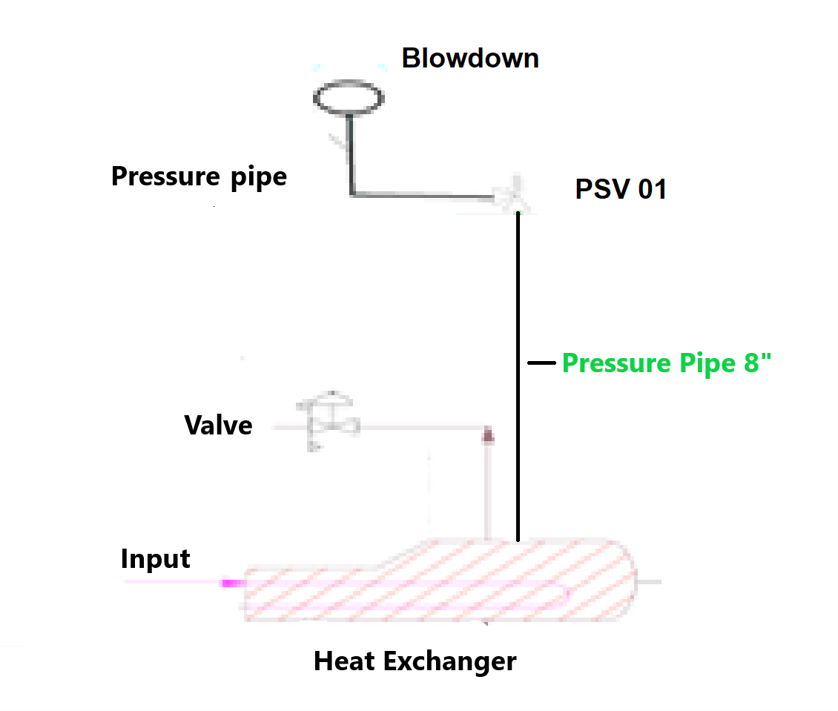

Figure 2: System diagram with a pressure pipe of 8" (DN=200 mm)

* 1. Conclusions

The purpose of this article is to introduce a risk assessment method for pressure pipes during operating phase, referred to a specific company/plant context. Using the proposed index method, it is possible to deduce if the risk, for a specific pressure pipe, is low, medium or high. If the risk is high or medium, the employer must put in place appropriate and specific prevention and/or protection measures in order to protect the safety and health of workers and citizens. In such cases, the employer must carry out a risk based inspection analysis, a methodology that provides the basis for making decisions supported by objective analysis regarding the most appropriate inspection frequencies, the extent of inspections and non-destructive checks.

References

Decree of the Ministry of Product Activities, No. 329, issued on December 1, 2004. Regulation providing norms to put into service and using pressure equipment and the assemblies defined by the Article 19 of the Legislative Decree n. 93 of 25 February 2000. Official Journal of the Italian Republic,Gen.Series no.22.

Decree of the Ministry of Labor and Social Policies issued on April 11, 2011. Regulation of the methods for carrying out the periodic checks referred to in Annex VII of the legislative decree of 9 April 2008, n. 81, as well as the criteria for the qualification of the subjects referred to in article 71, paragraph 13, of the same legislative decree. Official Journal of the Italian Republic, General Series n. 98 (April 29, 2011).

European Communities, 1997. Directive 97/23/EC of the European Parliament and of the Council of 29 May 1997 on the approximation of the laws of the Member States concerning pressure equipment, Official Journal of the European Communities, L181, Vol. 40, p.1-55.

European Union, 2012. Directive 2012/18/EU of the European Parliament and of the Council of 4 July 2012 on the control of major-accident hazards involving dangerous substances, amending and subsequently repealing Council Directive 96/82/EC (SEVESO III), Official Journal of the European Union, L197, p.1-37.

European Union, 2014, Directive 2014/68/EU of the European Parliament and of the Council of 15 May 2014 on the harmonization of the laws of the Member States relating to the making available on the market of pressure equipment (recast), Official Journal of the European Union, No. 189, 27.6.2014, p. 164–259.

Legislative Decree 81/08: Legislative Decree 9 April 2008, No. 81, as modified by Legislative Decree 3 August 2009, n. 109. “Implementation of Article 1 of Law 3 August 2007, no. 123, concerning the protection of health and safety in the workplace”, Official Journal of the Italian Republic, General Series n. 101, April 30, 2008 - Ordinary Supplement n. 108; Supplementary Decree: Official Journal of the Italian Republic, General Series n. 180 (August 5, 2009), Ordinary Supplement n. 142/L.

Muratore A., Giannelli G., Nastasi V., Sferruzza G., Grillone G., 2021, Risk assessment of pressure equipment during use phase, Proceedings of the 31th European Safety and Reliability Conference, Angers, France, 19-23 September 2021, ESREL2021 Organizers, Publisher: Research Publishing, Singapore. ISBN: 978-981-18-2016-8, pp.2420-2425, doi: 10.3850/978-981-18-2016-8\_305-cd.

Orsi F., Guerriero G., Pietrantonio E., 2015. La Valutazione del Rischio Chimico (“Chemical Risk Assessment”, in Italian language). EPC Editore, ISBN 978-88-6310-673-2, 656 pp..